**GIT AND GITHUB**

**Assignment**

**Section 1: -**

1. Create a directory ‘project_dir’ and cd to ‘project_dir’.

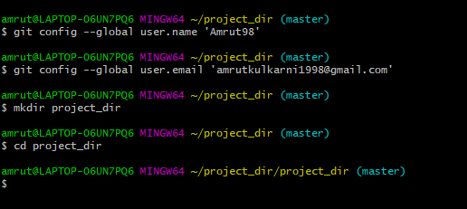

2. Initialize git version database.

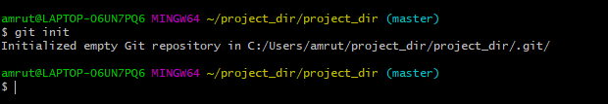

3. Create a new file index.html

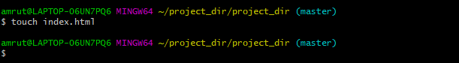

4. Check the git status.

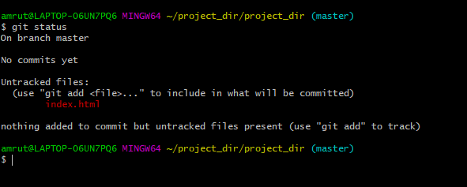

5. Stage the index.html



6.Commit index.html

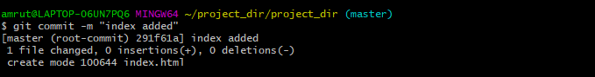

7. Make few changes in index.html and create new text file info.txt

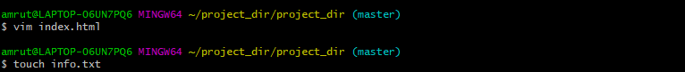

8.Check git status.

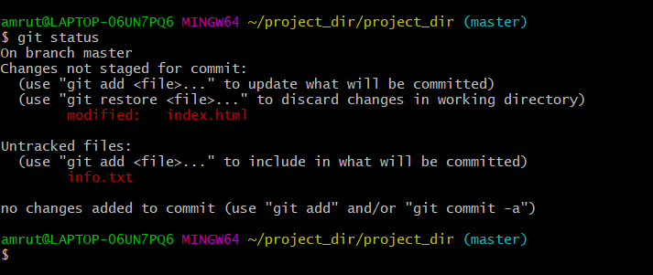

9. Configure GIT to ignore all txt files. And check the status

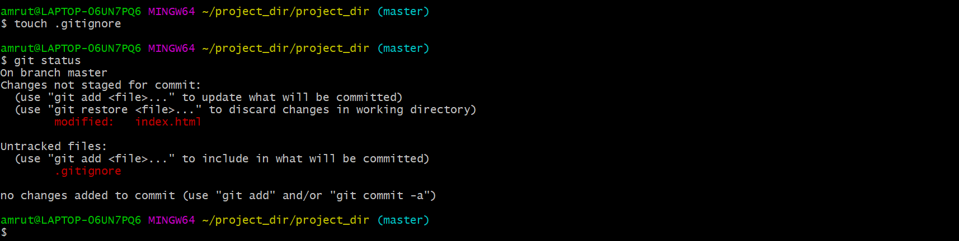

10. Stage & commit index.html

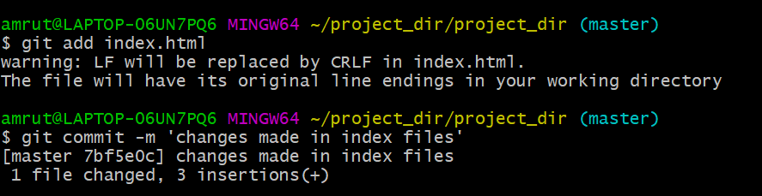

11.Log all your comments so far

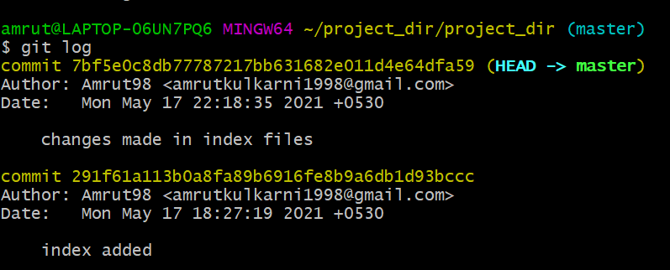

12. Again change index.html

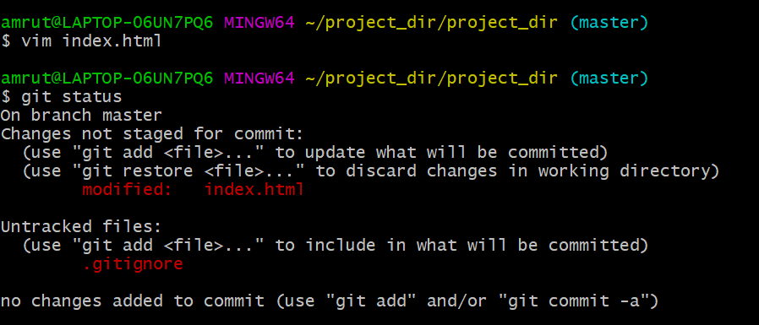

13. Revert (Undo) the changes made in previous step using git command



14. Again change index.html

15. Stage index.html

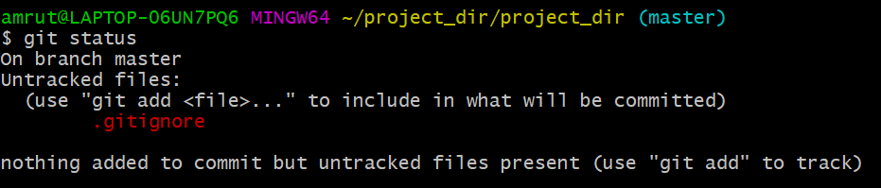

16. Revert changes

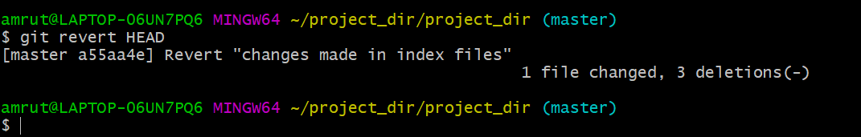

17. Rename Command and use

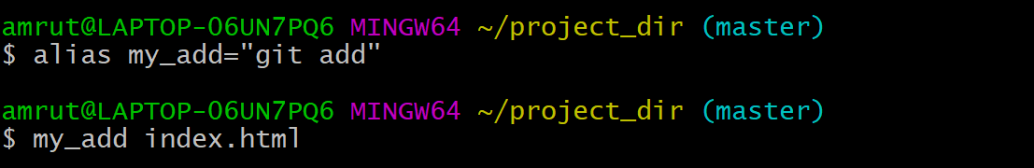

18. Revert changes



**Section 2: - HTML Assignments**

1.Making directory

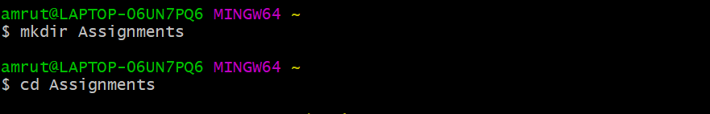

2.Creation of text file **README.txt** 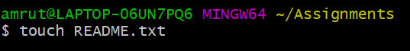

3.Commit **README.txt** file

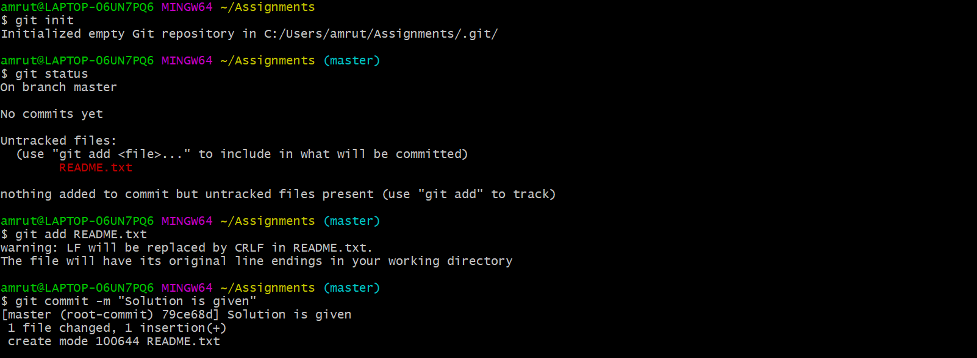

4.Creation of new branch **html-assignments** and switching to new branch

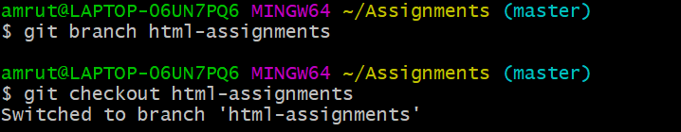

5.Commit assignments in new branch.

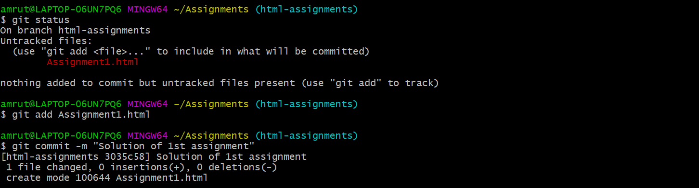

6.Make minor changes and commit those

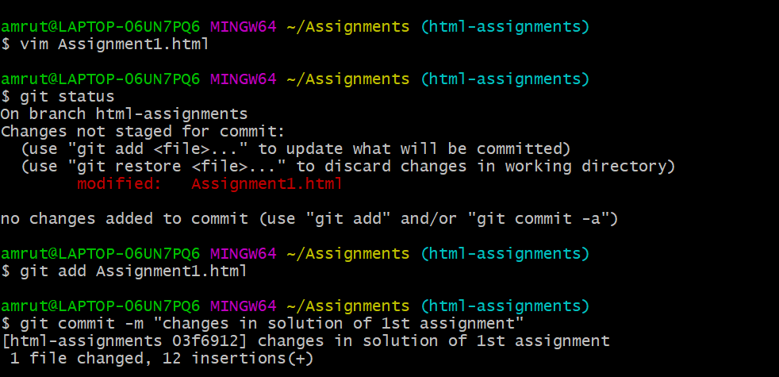

7.Switch to **master** branch

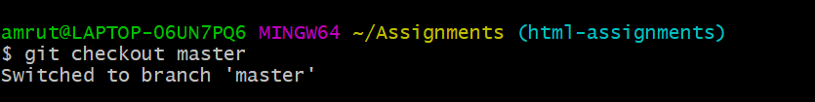

8.Make changes in **README.txt** and commit.

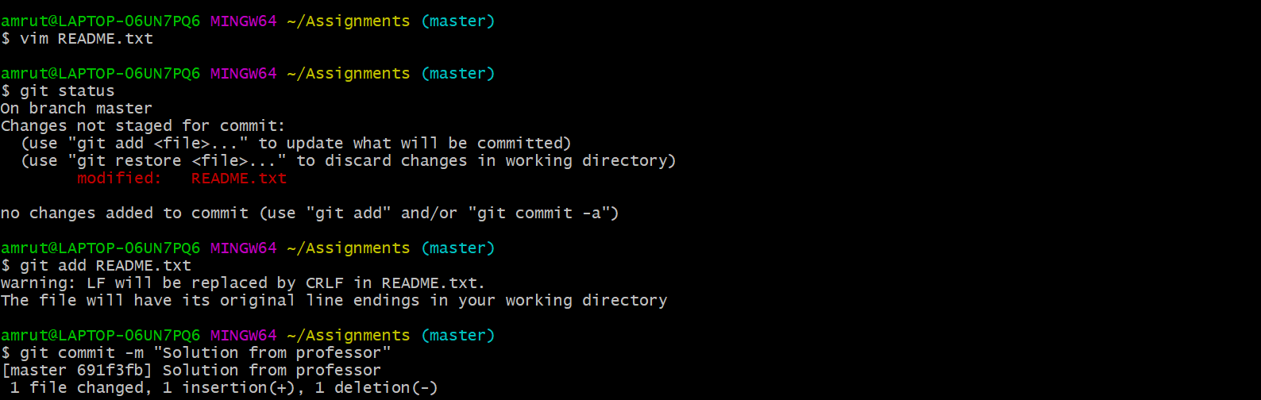

9.Switch to **html-assignments** branch

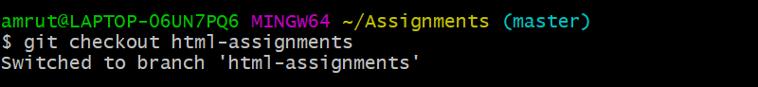

10.Make changes in Assignment1 and commit.

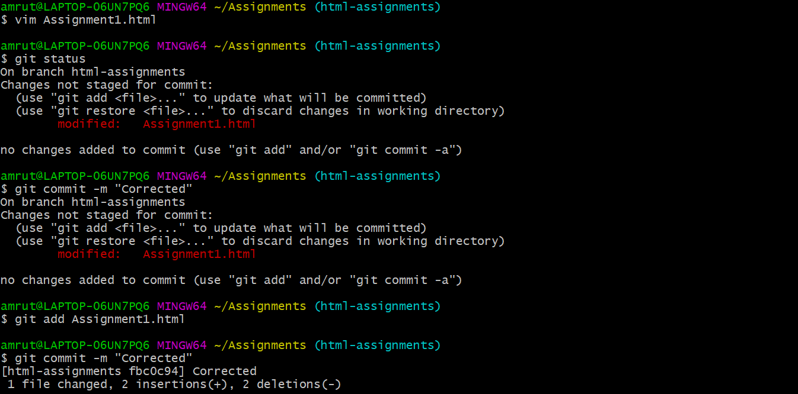

11.Switch to **master** branch.

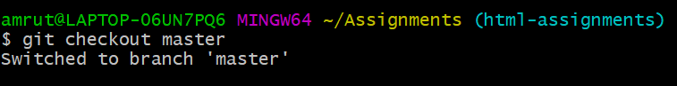

12.Merge **html-assignments** branch into **master**, and delete **html-**  **assignments** branch

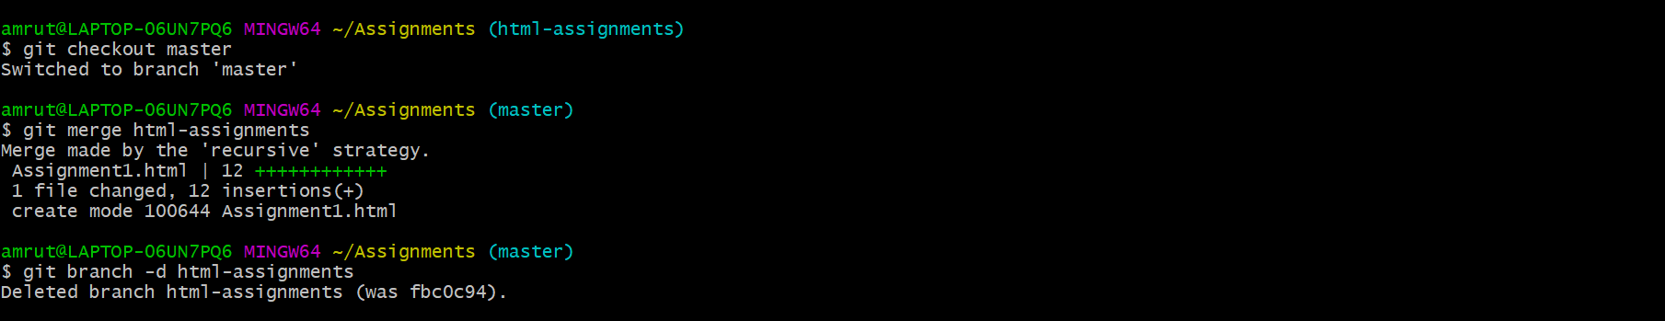

**Section 2: - CSS Assignment**

1.Create a new branch **css-assignments** and switch to **css-assignments.**

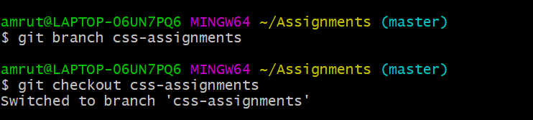

2.Commit Assignment2.css

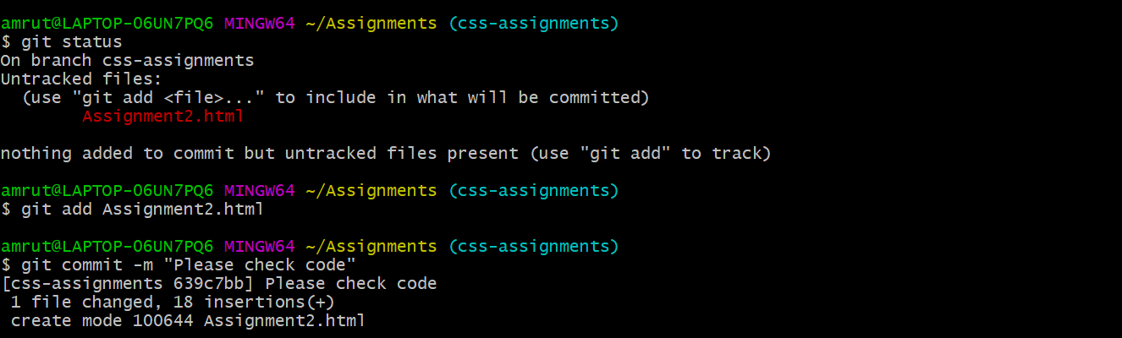

3.Changes in **README.txt** file and commit the changes.

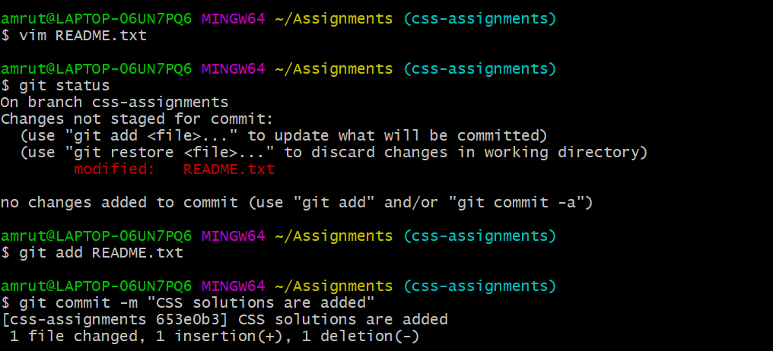

4.Switch to **master** branch.

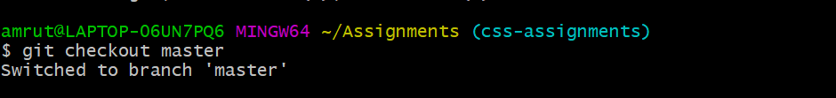

5. Changes in README.txt and commit

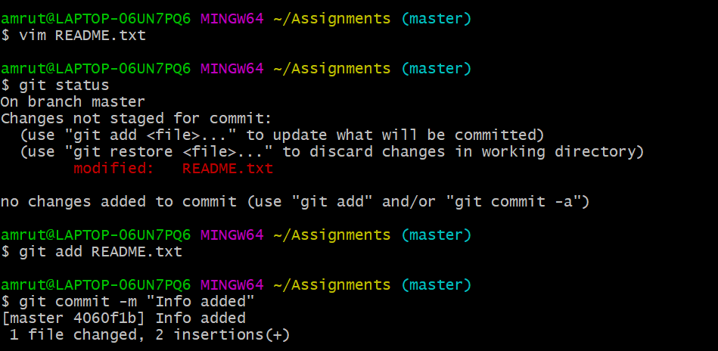

6.Swtich to **css-assignments.**

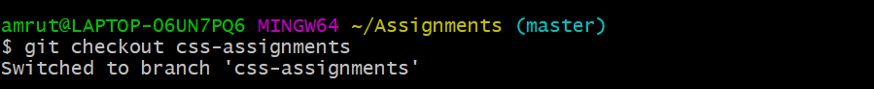

7.Make changes and commit

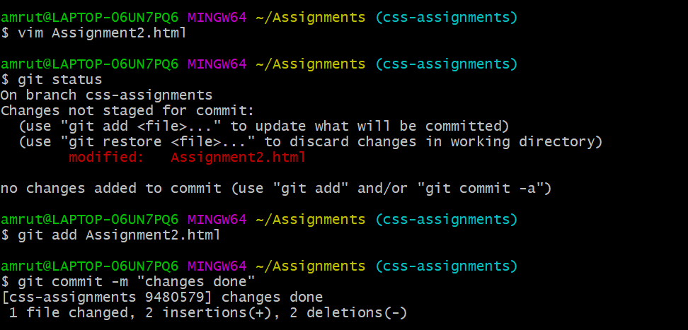

8.Switch to **master** branch.



9. Merge **css-assignments** into **master** branch, and delete **css-assignment** branch.

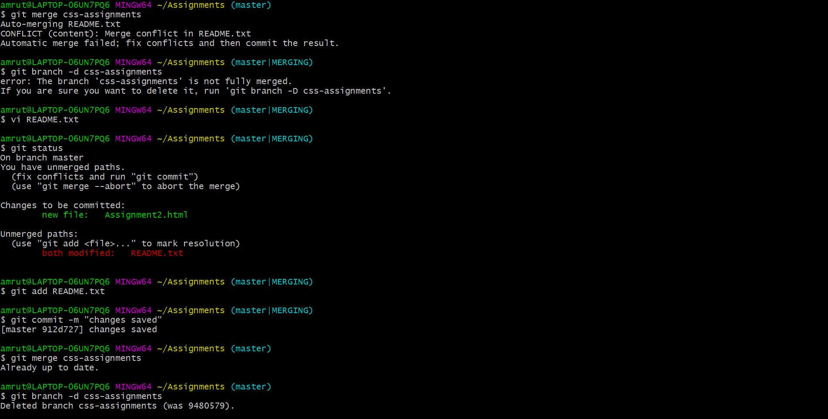

**Section 3: - JavaScript Assignments**

1.Create a new branch **js-assignments** and switch to **js-assignments.**

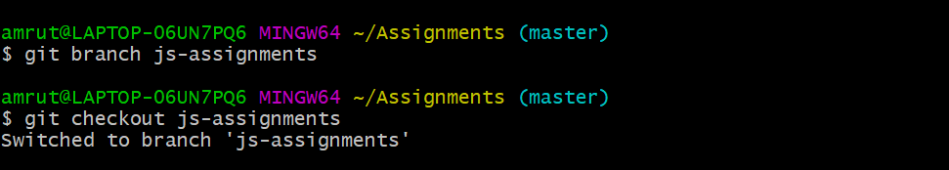

2.Commit Assignment3.json

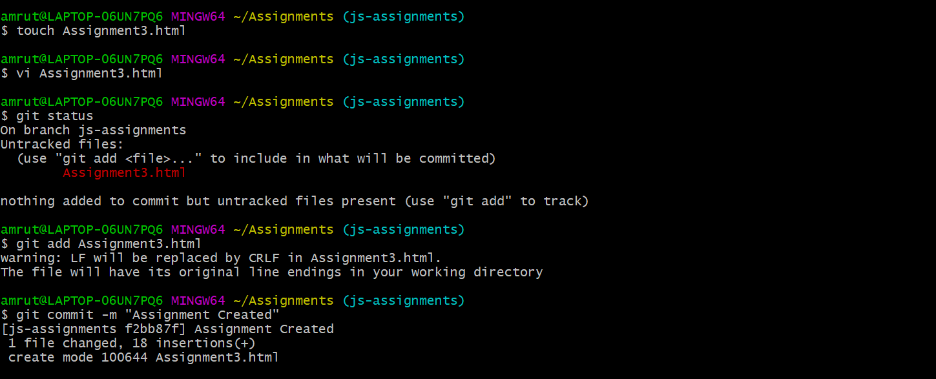

3. Changes in **README.txt** file and commit the changes.

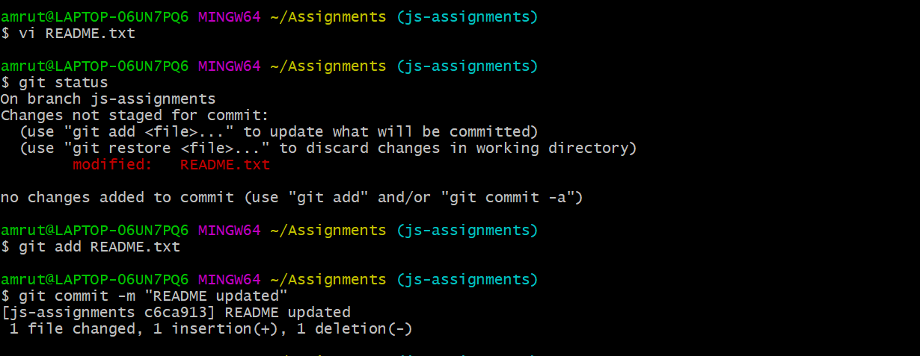

4.Switch to **master** branch.



5. Changes in README.txt and commit

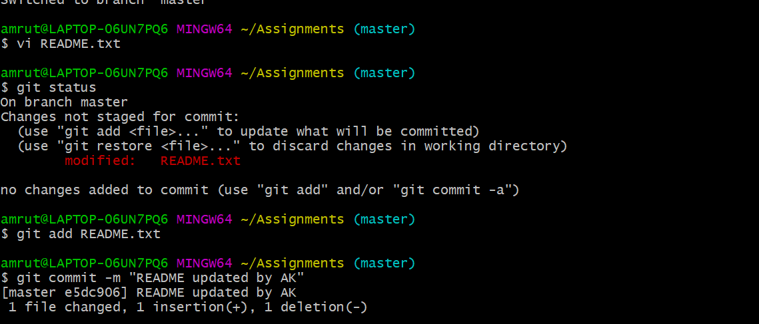

6.Switch to **js-assignments.**



7.Make changes and commit.

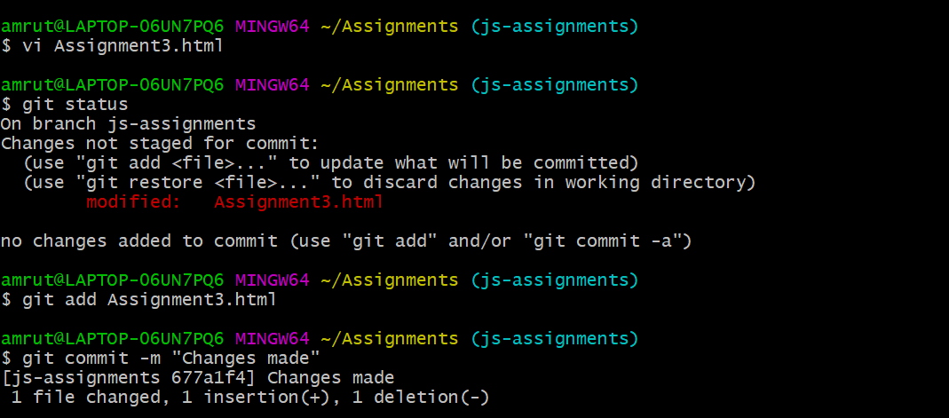

8.Switch to **master** branch.



9. Merge **js-assignments** into **master** branch, and delete **js-assignment** branch

